A sport facilities strategy template

The Office of Sport has developed this template to assist NSW state sporting organisations in their planning for sport facilities. It is designed as a guide only. It can be adapted according to the size and requirements of the respective state sporting organisation. The template can be used to develop a facilities strategy that is for internal purposes only, or publicly available. The proposed audience depends on the sensitivities of the content included.

This template complements existing resources provided by the Office of Sport that are available at:
https://sport.nsw.gov.au/clubs/rysso/strategy

Facility strategies do not need to be overly long or extensively complex. Effective strategies are often written with simplicity that is underpinned by data, research and consultation. The scope of the facility strategy should reflect the size and capacity of the state sporting organisation. They are to be developed as a ‘live’ document, that is continually used to guide planning and investment, and be updated regularly.

Whilst a comprehensive approach and process is strongly encouraged, a simple condensed version of the strategy can also be beneficial in communicating key priorities within 1-2 pages. Refer to Hockey NSW example on page 15.

There is no statutory requirement for state sporting organisations to develop a facilities strategy. However, such a strategy is integral to the long term planning of facility provision and leveraging key stakeholder investment. Facility strategies have direct impacts on participation and the long term sustainability of the organisation.

Name of your organisation logo

Title of the strategy

Period of the strategy i.e. ‘2020-2024’

Date Approved:

Business contact details
Telephone:
Email:
Website:

Contents
List the content of the facilities strategy and relevant page numbers. If using Microsoft Word, instructions on how to do this can be found here - Table of Contents Instructions
Potential contents for consideration include:

Acknowledgments
Welcome / Foreword
Executive Summary
Recommendations, proposals or action/implementation plan
Introduction and background – about the strategy
Guiding principles
Strategic context
Strategic alignment – NSW government regions
Value of sport
Network of facilities
Facility design guidelines
Inclusive facilities
Existing situation – providing the evidence base
Determining facility needs
Engagement
Partnerships
Infrastructure priorities
Funding and asset management
Implementation and review.

Acknowledgement of Country
An 'Acknowledgement of Country' can be given by both non-Indigenous people and Aboriginal and Torres Strait Islander people and is a way to show awareness and respect for Aboriginal culture and heritage as well as the ongoing relationship the traditional owners have with their land.
An Acknowledgement should ideally be placed on the inside front cover, standing alone, in a place of significance. For NSW, consider having an Aboriginal athlete from your sport write the Acknowledgement.
https://www.creativespirits.info/aboriginalculture/spirituality/welcome-to-country-acknowledgement-of-country
Acknowledgements
The development of strategic documents normally requires collaboration with multiple organisations. It is important to acknowledge those that have contributed. This may include:

- National Sport Organisation
- Affiliated Associations / Clubs
- Government Agencies
- Consultants
- Other partners.

Using logos is a visually powerful way to acknowledge organisations.
Welcome / Foreword
The welcome or foreword is typically written by the Chief Executive Officer or General Manager. It provides a brief overview of the plan and its importance in achieving the organisation’s broader strategic vision.
This section often includes an image of the person and contains their signature as an indication of the strategy’s endorsement by the organisation.
Executive Summary
An executive summary is a short section that summarises the document in such a way that readers can rapidly become familiar with the contents and intent of the plan without having to read it all. It provides essential information concisely, in an easy to understand format and is typically no more than one page in length.
In developing an executive summary, consider the following contents:
- What is the strategy about?
- Why the strategy has been developed?
- The intended timeframe of the strategy, for example 2020-2025
- What were the key findings?
- What more needs be done? OR How will these findings be applied?
While the executive summary is at the beginning of the document, it should be written last. In doing so, it will reflect a better understanding of the situational analysis for your sport facilities and articulate proposed solutions with greater conviction and persuasion.
Recommendations, proposals, or an action/implementation plan
Too often, recommendations are placed at the end of a document. This makes it difficult for the reader to quickly understand what the strategy is proposing and how it relates to the reader’s interests or needs.
Recommendations should be easy to understand and can be listed in various formats. Some items to consider when listing recommendations:
- Grouping recommendations into key themes and potential use of graphics
- Use prioritisation such as high, medium or low
- Articulate associated timings e.g. year 1, year 3.
The use of the SMART acronym should be applied:
S - specific, significant, stretching
M - measurable, meaningful, motivational
A - agreed upon, attainable, achievable, acceptable, action-oriented
R - realistic, relevant, reasonable, rewarding, results-oriented
T - time-based, time-bound, timely, tangible, trackable.
Example recommendation: “Work with affiliated associations, clubs and local government to complete a state-wide facility audit by December 2020”.
Introduction and background – about the strategy
This section provides the opportunity to provide more information about the facilities strategy, what it contains, its outputs and the back-story to why it has been developed.
The methodology, or “how the strategy was developed” can also be articulated in this section. This may include related projects such as:
- Organisation wide strategic plans
- Reviews or analysis of existing business operations i.e. organisation health checks
- Stakeholder engagement / consultation
- Facility audits
- Participation data analysis
- Broader data analysis e.g. population trends etc.
A standalone section on methodology can also be placed here. Alternatively, the Appendix of the strategy can provide more details about how the document was developed.
Guiding principles
Guiding principles help provide an overarching direction for the strategy. They ensure the strategy is aligned to the organisation’s values. Guiding principles could include:
- Equitable access for all users
- Optimising use of existing facilities
- Adequate provision to meet demand
- High quality to meet user expectations
- Partnerships
- Asset management
- Sustainable investment models.
Strategic context
This is a chance to demonstrate how the facilities strategy fits into the overarching planning framework for your sport. The facilities strategy could be linked to:
- National Sport Organisation Strategic Plan
- Your organisation’s strategic plan
- Participation growth plans, and
- Facility design guidelines.
The use of graphics or a table could be used here with the facilities strategy placed in the middle of the section showing its relationships above (such as National Sport Organisation Strategic Plan), laterally (such as participation growth plans), and below (such as how this plan influences association or club plans).
Strategic alignment – NSW Government Regions and Local Government Areas
NSW has 10 distinct regions which are aligned with local government areas. Developing sport facility strategies consistent with these regions and local government areas will help enhance alignment in planning and investment. https://www.nsw.gov.au/improving-nsw/regional-nsw/our-regions/
Greater Sydney is further divided into five districts: https://www.greater.sydney/district-plans
Strategic alignment should also consider the relationship with the directions of government and non-government plans. Plans to consider strategic alignment with include:
- Sport 2030 - by Sport Australia
- Australia's Physical Activity and Sedentary Behaviour Guidelines
- NSW State Plan and the Premier’s Priorities
- Office of Sport - Strategic Plan and other relevant strategies and plans
- Future Directions - by Sport NSW
- Regional and District Plans
- Local Government Strategic Planning Framework and Local Strategic Planning Statement
- Council Recreation, Open Space and Sports Strategies
- Council Asset Management Plans.
Value of Sport
Some sport organisations have engaged third parties to undertake an economic impact assessment for their sport. This often involves key figures around for every dollar invested into the sport, an economic output of $X is generated. The use of these assessments can be a powerful tool to justify investment into your sport facility projects.
If your organisation has not undertaken such an assessment, then reference to Sport Australia’s ‘The Value of Community Sport Infrastructure’ can be made. This report is available at:
www.clearinghouseforsport.gov.au/__data/assets/pdf_file/0007/804067/VoCSI_Final_June_2018.pdf
Network of sport infrastructure
An infrastructure network (previously referred to as a ‘hierarchy’) is a framework that guides what type of facility will meet the needs of the catchment it serves and to assist in creating an approach to limit facility duplication. The type of facility will inform the partnerships required to make it a successful and sustainable facility, as well as influencing the design, cost and service mix.
The network of facilities is closely linked to the level of competition and athlete pathways. The Office of Sport has developed the below draft Network for sport infrastructure provision. It is recommended that this be used in planning for your sport.

- International, national & state
- Centres of excellence
- High performance centres
- Sport administration centres
- Regional facilities
- District facilities
- Local facilities
- Neighbourhood facilities.
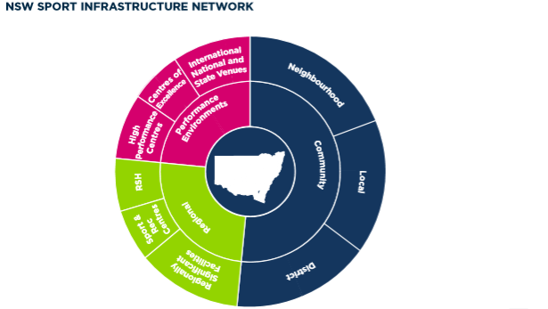
Refer to Appendix 1 for details on the sport infrastructure network.
Facility design guidelines
Does your organisation or national body have facility design guidelines? If so, this is a good opportunity to provide a summary of the guidelines including minimum standards. A link can then be placed on where the reader can find a copy of the full guidelines. Commentary on relevant standards is also recommended including Australian Standards, Building Codes etc.
If you do not have facility design guidelines, this is a good opportunity to provide some basic details on what makes an ideal facility. Things to consider include:
- Dimensions of the field of play including safety zones. This may vary for certain age categories and/or standards of competition
- Types of facility surfaces
- Amenity building requirements such as toilets, canteen, change rooms, referee/umpire room, medical room and storage. This should ideally include square metre requirements for each functional space. Larger buildings may also include function room, meeting rooms etc.
- Requirements for officials, volunteers etc.
- Lighting requirements for training and competition
- Preferred layout and orientation of the field of play
- Ancillary facilities such as practice infrastructure, and
- Other supporting infrastructure such as shade/shelter, drinking water, parking etc.
Facilities should be planned and designed to be inclusive for all. They should be inviting and accessible for all abilities, all genders and all ages. Facility design standards should vary according to the network i.e. the facility requirements for national competitions will be significantly different to local club-based competitions.
A range of existing state sporting organisation facility guidelines can be found at the Office of Sport Community Sport Infrastructure Resource Library: https://sport.nsw.gov.au/aboutus/OOS/SIG/resource-library/design/outdoor
Inclusive facilities
Facilities should be planned, designed and managed to be inclusive of all population groups. Participation in sport is continually evolving.
One significant trend is the rise in female participation in sport. Her Sport Her Way affirms the NSW Government’s commitment to empower women and girls to have full access to opportunity and choice, be valued for their diversity, be recognised for their contribution, and be able to participate in all aspects of sport. As identified in Her Sport Her Way, planning for sport infrastructure in NSW must enable equal access to high quality sport infrastructure to:
• Grow women and girls’ participation in sport (including officials, coaches and volunteers)
• Improve high performance outcomes
• Drive sport-related tourism, and
• Foster sector sustainability and business outcomes.

Facilities should also consider accessibility for people with disability, ensuring equitable access for all. Understanding baseline data on the existing state of play of facilities and their capacity to cater for all population groups is a crucial first step.

When applied well, inclusive design principles maximise the potential of a facility to allow for greater access and greater use by all participants. More information on universal design is available at:
https://sport.nsw.gov.au/aboutus/OOS/SIG/resource-library/design/best-practice-principles#UniversalDesign

Existing situation – providing the evidence base
A facility strategy provides a framework on moving from an existing situation towards a desired position. To achieve this, a strong evidence base is needed to support the recommendations and proposed directions. This evidence is often in the form of good quality data and analysis. This section is where the results of studies and analysis can be included. It can include items such as:
- SWOT analysis – what are the Strengths, Weaknesses, Opportunities, and Threats in relation to your sport facilities. A PESTLE analysis can further assist with the analysis of the Opportunities and Threats
- Facility audit findings
- Consultation and /or survey findings
- Current participation numbers, trends and benchmarks
- Demographics such as age, gender, ethnicity, mobility, family structure, education, disposable income, housing type etc, and
- Existing association boundaries or planning zones.
Should your organisation not have data to help inform an analysis, then there are two broad options:
- Seek the required data to make informed decisions within the strategy
- Place it down as a recommendation noting that this strategy will be updated once the data is collected and analysed.
If your sport is seeking to gain a better understanding on data, these tips may help.
Facilities
Consider capturing a range of data, in a consistent format. This could include the following:
- Site name
- Street address, suburb and postcode
- The local government area, state and federal electorates the site is located in
- GPS location including latitude and longitude
- Land owner and facility owner (if different to land owner)
- Who manages the site?
- Facility network – local, state or national standard facility. Refer pages 5-6.
- Who is the primary user, and who are the secondary users of the site? Both sport and non-sport use.
- Number of full-sized equivalent fields/courts/lanes etc.
- Quantity of ancillary facilities such as practice nets, junior or modified fields over and above the full-sized equivalent fields, scoreboards, interchange benches, goals, siren etc
- Lighting lux levels
- Surface type - for example, tennis has multiple surface types
- Quality of the facility including drainage and irrigation (for playing fields)
- Functional areas of the amenities building including female friendly facilities, all-abilities accessibility, officials change room and toilet, first aid room etc.
- Functional areas of the pavilion such as spectator seating, canteen, meeting rooms
- Age of amenities building
- Quantity of car parking spaces
- Site history such as date of construction, and
- Other supporting infrastructure such as shade/shelter, drinking water, parking etc.
Participation
Participation data is essential to understand existing demand and help anticipate future facility requirements. Participation data should (generally) include:

- Member ID
- Member’s name
- Member’s home address including suburb and postcode
- Membership type - player, coach, official etc.
- Membership level – player full season, school based programs etc.
- Club and association name
- Date of birth / age and age category
- Gender
- If the participant identifies as Aboriginal or Torres Strait Islander, and
- Language spoken at home.

Where possible, it is extremely beneficial to understand visitation/asset utilisation for each member and non-member. This helps determine with accuracy the impact on sporting facilities i.e. 100 members who use a facility for 30 minutes a week will have a different impact compared to 100 people who use the facility for four hours a week.
Data tips:
- Understand your ‘why’ – It is important to understand why the data is required in the first place. This will help shape your preparation of data analysis.
- It’s all in the preparation – Take the time early in the process to ensure the type of data being captured is what is needed to answer your why. How it will be used? What do you hope to achieve with the data? What is the best way to capture, store and analyse the data?
- Consistency is key – establish processes to ensure data captured is in a consistent format and is routinely updated to ensure relevance.
- Consider inclusive environments – Do your amenities have gender neutral change rooms, does your facility cater for people with disability in a dignified manner? Further information Design for dignity guidelines
- The use of automated fields for details such as addresses will ensure consistency and reduce errors, making data cleaning and analysis more efficient and accurate
- Quality assurance – Establish systems that allow your data to be validated and reviewed on a regular basis.
There are a range of free data platforms that can assist with data analytics and visualisation. Platforms like Google Charts, Tableau, D3.js, Datawrapper and Raw are just a few options available.
The Office of Sport can also assist in mapping facilities, especially when facility location data is available. Email us at: contactfsp@sport.nsw.gov.au
Alternatively, a graphic designer can be engaged to produce maps that visualise the current state of play for your sport facilities.
In addition, National Maps provides various layers of data at no cost: https://nationalmap.gov.au/
Engagement
Meaningful engagement with stakeholders is critical in the development of a facilities strategy. It helps understand their challenges, identify opportunities and understand future aspirations. A ranging scale of engagement can be undertaken that includes:
- Inform – Provide stakeholders with information about the project
- Consult – Request and obtain feedback on the draft strategy
- Involve – Work directly with stakeholders on challenges, opportunities and aspirations, ensuring they are continuously understood and incorporated into the strategy
- Collaborate - Partner with stakeholders in each aspect of the process including the development of alternatives and the identification of the preferred direction of the strategy.
The International Association for Public Participation may be of assistance in developing an engagement plan: https://www.iap2.org.au/
Stakeholders to consider during this process include:
- Players, coaches, officials and volunteers
- Clubs and Associations
- National Sport Organisation
- Local government and other facility owners
- State government, in particular the Office of Sport
- Other State Sporting Organisations, especially where facilities are shared
- Member associations such as Sport NSW and Parks and Leisure Australia, and
- Sponsors and other financial advisors.

Determining facility needs
Determining facility needs should include all types of infrastructure used by your sport and be linked to the preferred facility guidelines (if developed). There are three main pillars to consider here:

Quantity – Do we have enough facilities to meet current and forecast demands?
Quality – Are our existing facilities of appropriate standards? Do they comply with our sport’s preferred facility guidelines? Can we increase their capacity?
Distribution – Are our facilities located in the right areas? Can the public access them easily?

To determine the quantity of facilities required, sporting organisation can use a simple calculation that involves:
- Knowing the location of existing facilities
- Understanding the optimal player to field/court/facility ratio e.g. 1 field to 200 players.
- Are there existing clubs operating at or above this optimal ratio?
- Determining current participation rates i.e. number of players divided by existing population. This can be further enhanced by evaluating participation rates based on specific demographics such as age.
- Using government population forecasts, what is the expected number of future participants in the next 5, 10 or 20 years? This can be determined by multiplying participation rate by expected population growth of a Local Government Area, District or Region. If more detailed analysis of demographics has been obtained, this can be used to enhance future needs-based modelling of facility demands.
- Calculate the number of new facilities required – expected number of new participants divided by the optimal player to facility ratio. For example, an additional 2,000 participants with an optimal player to field ratio of 200 would equate to 10 additional fields being required.
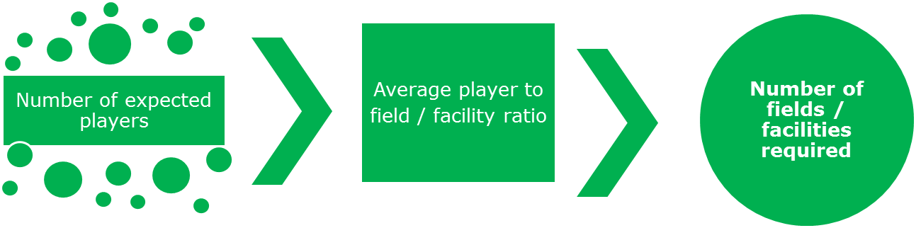
In determining capacity, there is a range of methods that can be used. This depends on the type of sport facility in question and the standard of competition that it provides for. Some areas for consideration:
- Number of participants per field / court
- Hours of use (natural surfaces v synthetic surfaces)
- Level of impact, for example, junior sport v senior sport, rugby v touch, summer v winter
- Standards of turf quality including soil profile, drainage, irrigation, turf coverage etc.
- Lighting standards
- Conditions of consent and facility use policies., for example, no bookings after 8pm due to proximity to residents
- Market insights regarding consumer/participation behaviour (local or global proxy).
Similarly, there is a range of solutions that can be considered to meet demands. This includes but is not limited to: reconfiguring playing fields; installation or upgrade of lighting; scheduling to spread utilisation; enhancing irrigation and drainage; installing synthetic surfaces; use of courts for football or hockey training; collaborating with education providers such as schools and universities; consider integrating facilities in mixed-use development; facility innovation and technology; conversion of car parks to sporting facilities; placing facilities on top of car parks or large buildings.

Partnerships
In a landscape where resources are scarce and competing interests both within and outside the sector are high, the ability to collaborate is essential. Identifying, establishing and maintaining partnerships is essential to maximise community benefits from investment into sport facilities.
Key partners you may wish to consider include:
- Other sporting codes – especially when facility requirements are similar
- Local government
- Office of Sport, and
- Department of Education / School Infrastructure NSW.
Partnerships can occur at various levels, from high level agreements such as memorandums of understanding, through to site-specific projects. Some codes such as Tennis NSW and Football NSW have entered a partnership agreement aimed at increasing the opportunities for their member clubs and associations to share access to existing tennis facilities across NSW.
Partnerships are based on mutually beneficial outcomes. Areas to consider in partnering include:
- Memorandums of understanding on sharing facilities
- Engagement of consultants when capturing and analysing data
- Grant applications for infrastructure works
- Facility usage agreements such as licences, and
- Facility priority listings that inform future planning (refer below).
Infrastructure priorities
Should your organisation have sufficient data, then a priority list of infrastructure requirements can be established. This can be used for targeting investments, entering future partnerships, applying for grants etc.
Some useful headings for such a list can include:

- Priority ranking
- Facility name
- Address including GPS coordinates
- Local government area / state electorate / federal electorate
- Project name
- If the project is new or an upgrade to an existing facility
- What the facility type is. For example, playing field, amenities, lighting etc.
- Short description
- Total estimated project cost
- Origin of project cost
- Current or proposed funding commitments.
When developing a list of priorities, consider how ‘project ready’ each infrastructure priority is. This includes:
- Facility planning (strategic outcomes, functional and technical briefs, alignment to policies, strategies etc)
- Feasibility and business case including concept designs with preliminary costings
- Master planning including quantity surveyor costings
- Detailed design documentation, and
- Development approvals and construction certificates.
The Office of Sport conducts the ‘Future Needs of Sport Infrastructure Study’ which requests the above information every two years.
Once a list of infrastructure priorities is developed, an infographic that illustrates the above data can be developed. This may take the form of a map of NSW with the regional boundaries, with call out boxes of high-level details for each project.
Funding and asset management
Whilst it is important to identify facility requirements and needs, it is equally important to develop a plan that ensures this can be achieved through sound funding models and asset management practices. Regardless of the facility ownership, it is imperative to have a clear funding and asset management plan that does not overly rely on other parties, including the facility owner.
Some key questions to consider in this section include:
- Do we understand the costs of construction, maintenance, renewal and disposal (where appropriate) of various asset types?
- What are the opportunities for collaboration with key partners to reduce costly duplication?
- How will we pay for the proposed infrastructure works?
- How will we fund the ongoing management and maintenance of the facilities we use?
- Do we have a mechanism such as an infrastructure sinking fund to help pay for asset renewal and replacement?
Implementation plan and review
In this section, you should briefly describe how the organisation plans to implement the strategy. It should describe the actions and timeframes involved as well as how the plan will be monitored and reviewed. For example, will there be quarterly updates to the Board? Will there be an annual review that is included in the organisation’s annual report?
The action plan can then be updated and revised to reflect the work completed and what the next list of priorities for the organisation are for the next one to two years.
In reviewing and evaluating the strategy, important questions to ask include:
- What does success look like?
- How will we know when we have achieved success?
- How is this success measured?
- What has worked well? What has not worked well?
- What lessons have we learnt? How can we improve over the next 12 months?
Whilst some organisations may implement their strategy over a three to five-year timeframe, other organisations review and update their implementation plan on an annual basis. This works on the basis that every year as actions are completed, the next priorities move forward, and additional actions are added. This ensures a working and living strategy that is continually being implemented for the benefit of the sport.

Appendix 1 – The Sport Infrastructure Network
International, national and state facilities
International, national and state facilities are the highest-level facilities capable of hosting international events and competitions, national leagues, and state or national team training centres. These facilities promote sports, provide entertainment and encourage community access and pathway opportunities for participants.
NSW residents are the primary users of these facilities, however they also attract users and visitors from interstate and overseas. National and/or state facilities within NSW include the venues defined in the NSW Stadia Strategy 2012.
Centres of excellence
Centres of excellence provide world-leading training and administration facilities so that clubs can build, attract and retain the best talent among athletes, coaches, executive and support staff. These facilities provide programs that identify and develop future elite players and help them achieve mastery in their sport. They are integral to talent and youth development pathways and may include an academy program.
A Centre of Excellence includes elite level training facilities, administration centre, and education and training rooms for codes and clubs. They may host games from junior level to professional, exhibition events and pre-season events. Centres of excellence give sport organisations a home base and can provide a competitive edge as they face greater competition and demands for better athlete services and better technology.
High performance centres
High performance centres provide world-leading training and administration facilities to develop, attract and retain the best talent among athletes, coaches and support staff. High performance sport and performance pathways drive participation in sport and attendance at major sporting events.
High performance centres should be adaptive and accessible, allow for flexible training methods, meet minimum competition standards, and encourage shared use across multiple sports. These spaces should also include relevant technological infrastructure that enables ongoing learning and analysis. Holistic education opportunities for athletes and coaches should be supported with education space or rooms that can be available to community groups and also available to athletes during and after their elite sport careers.
Sport administration centres
The clustering of sport administration and sports services provides for greater efficiencies, collaboration and coordination across organisations. Examples include Sports House at Sydney Olympic Park.
Regional facilities
Regional facilities integrate competition and recreation. They should be accessible, with links to transport, commercial and community centres. The primary catchment of regional facilities are local users with an extended catchment across multiple local government areas, primarily for competition and events. They include regional sporting hubs, regionally significant sport facilities, regional academies of sport and sport and recreation centres.
A regionally significant sports facility is typically a single sports facility that attracts participants, officials and spectators from across the region. Using the Hub and Spoke model, regionally significant sport facilities will be in outlying towns and centres surrounding a regional sport hub location.
Regional sport hubs focus on improving sport facility access between regional cities and centres giving communities and athletes access to quality facilities, coaching and training. Regional sport hubs are multiple sport facilities co-located on one site. They might include sub-elite sport support services and sport administration offices and could incorporate centres of excellence and community facilities. They can also bring new social or economic opportunities to a region.
Ideally, regional sport hubs are single precincts with all components on one site, depending on land availability. Alternatively, regional sport hubs could be a network of facilities and services in one regional town or city, with a main site or hub incorporating both core and support facilities. Regional sport hubs represent an integrated and coordinated approach to sport and recreation facilities, avoiding duplication and optimising investment.
District facilities
District facilities cater for association competition, hosting local finals or acting as a central venue for regular competition for multiple clubs and/or teams. They comprise a mix of recreational, competitive and program formats. The primary catchment area includes local communities within a large local government area or across multiple local government areas. The development of five District Sport Facility Plans for Greater Sydney provides an opportunity to identify the network of facilities across and within districts.
Local facilities
Local facilities service the needs of the local community and sporting clubs for home and away fixtures, social sport, training activities and participation programs. The primary catchment area includes single local government areas or multiple suburbs.
Neighbourhood facilities
Neighbourhood facilities are small sites in local communities that provide basic facilities and landscape treatments. They are typically provided in residential settings and have limited or constrained function for multiple activities. The primary catchment area is usually within walking distance of most users.

Appendix 2- Additional information

Facility Strategy Examples

Netball NSW – Statewide Facilities Strategy 2018-2033
Queensland Cricket – Infrastructure Strategy 2018-2028
Football Federation Victoria – State Football Facilities Strategy to 2026
Lacrosse Victoria – Strategic Facilities Plan 2016
Volleyball Victoria – State Facilities Strategy

Community Sport Infrastructure Resource Library
A practical resource to assist in the planning, design and construction of innovative, sustainable and fit for purpose community sporting infrastructure.
https://sport.nsw.gov.au/aboutus/SIG/resource-library

Her Sport Her Way - Participation Planning Tool Resources
A compilation of resources on a broad range of topics relating to women and girls in sport is available at the Office of Sport website:
https://sport.nsw.gov.au/clubs/participation-planning-tool/resources

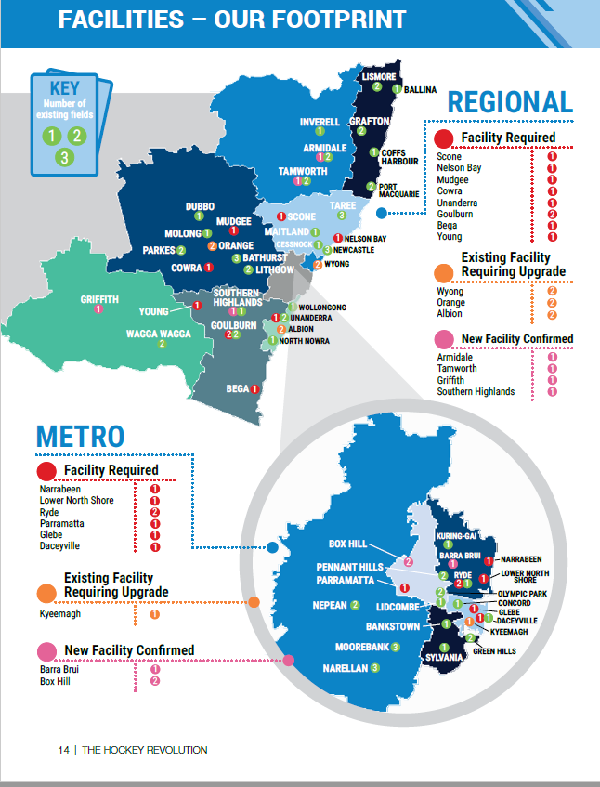
Info-graphic example - Hockey NSW
