Shoosh for Kids – Social Media Posts
Open the images from the Shoosh for Kids winter resources page on the Office of Sport website, right click > Save as image can be used for Facebook and Instagram - Shoosh for Kids winter resources | Office of Sport (nsw.gov.au)
An example of the social tile + Shoosh for Kids copy:
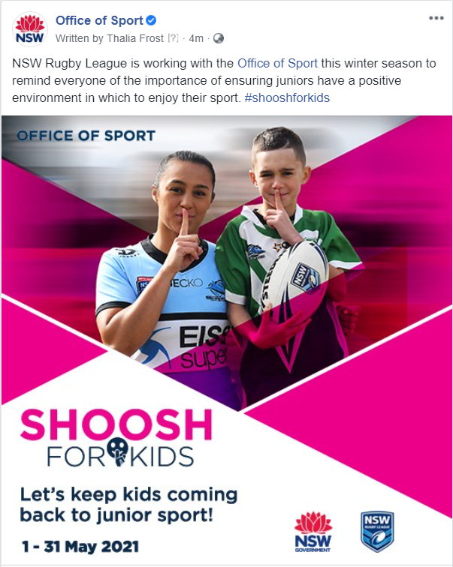

Suggested copy/posts
Find below some suggested copy to accompany the images on the previous page. Feel free to write your own or create your own image using spectators or members.
- Shoosh for Kids is back and bigger than ever! For the month of May, help spread awareness of Shoosh for Kids and encourage positive spectator behaviour.
Let’s keep kids coming back to junior sports! #shooshforkids
- Shoosh for Kids isn’t about staying completely silent - In fact, positive spectator behaviour is encouraged. Cheering on both sides of the competition is encouraged.
And remember, sport should be fun! #shooshforkids
- Shoosh for Kids isn’t about keeping quiet at a game – it’s a reminder that, when it comes to junior sport, if you haven’t got anything nice to say, don’t say anything at all. Let’s keep our comments positive and keep kids coming back to sport. #shooshforkids
- There’s nothing worse than the negative behaviour of someone on the watching ruining it for everyone. Get involved in the state-wide campaign to keep comments positive at junior sport – remember, sport should be fun! #shooshforkids
- {INSERT SPORT NAME HERE} is working with the @Office of Sport this winter season to remind everyone of the importance of ensuring juniors have a positive environment in which to enjoy their sport. #shooshforkids
- This winter season, we’re asking spectators to remember that sport should be fun and to show respect to kids and officials. #shooshforkids
- Keeping the environment positive at junior sport keeps kids coming back and everybody happy. We’re reminding everyone this season to keep their comments from the sideline positive! Support the initiative by hashtagging #shooshforkids

